Hi, I’m/We are one of your neighbours who is interested in creating a more connected, friendly and happy neighbourhood.

If you like the idea of knowing more people, sharing resources and ideas and getting to know each other, please join us to say hello.

**Where: <insert venue name and address>**

**When: <insert day, date >**

**@ <insert time>**

Please contact me/us on xx - phone or xx - email to RSVP.

If you can’t come but would like to be involved in future events (participating or organising), please let me/us know.

I/we look forward to meeting you. <Name/s>

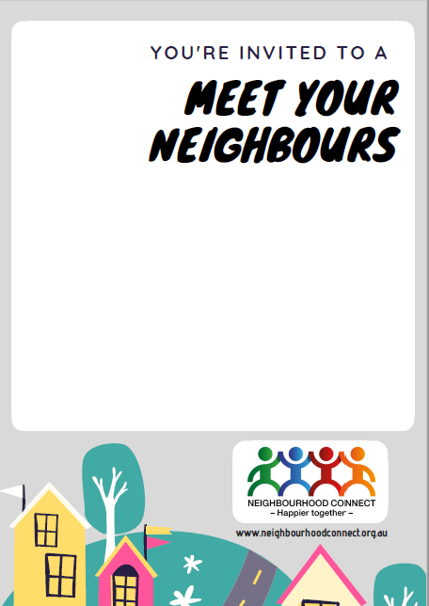

Hi, I’m/We are one of your neighbours who is interested in creating a more connected, friendly and happy neighbourhood.

If you like the idea of knowing more people, sharing resources and ideas and getting to know each other, please join us to say hello.

**Where: <insert venue name and address>**

**When: <insert day, date >**

**@ <insert time>**

Please contact me/us on xx - phone or xx - email to RSVP.

If you can’t come but would like to be involved in future events (participating or organising), please let me/us know.

I/we look forward to meeting you. <Name/s>

