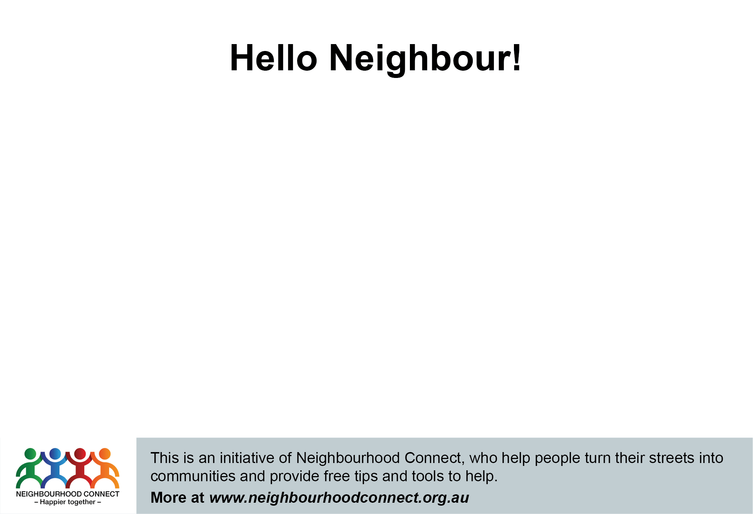

Hi, I’m < Insert name>, one of your neighbours on <Insert street name>. The coronavirus has made many of us realise how important our neighbours are ...so I'm reaching out to stay connected.

We can't get together in person right now, but we can: have a chat; run errands; share ideas; try some creative ways to socialise and eventually, get to know each other and meet in person.

Please call .................... or email ………….....(optional)<or join the new Facebook Group at [www.Facebook.or/neighbourgroup](http://www.Facebook.or/neighbourgroup)> and I will be in touch for next steps.

Look forward to meeting you!

**Hello Neighbour!**

Hi, I’m < Insert name>, one of your neighbours on <Insert street name>. The coronavirus has made many of us realise how important our neighbours are ...so I'm reaching out to stay connected.

We can't get together in person right now, but we can: have a chat; run errands; share ideas; try some creative ways to socialise and eventually, get to know each other and meet in person.

Please call .................... or email ………….....(optional)<or join the new Facebook Group at [www.Facebook.or/neighbourgroup](http://www.Facebook.or/neighbourgroup)> and I will be in touch for next steps.

Look forward to meeting you!



Hi, I’m < Insert name>, one of your neighbours on <Insert street name>. The coronavirus has made many of us realise how important our neighbours are ...so I'm reaching out to stay connected.

We can't get together in person right now, but we can: have a chat; run errands; share ideas; try some creative ways to socialise and eventually, get to know each other and meet in person.

Please call .................... or email ………….....(optional)<or join the new Facebook Group at [www.Facebook.or/neighbourgroup](http://www.Facebook.or/neighbourgroup)> and I will be in touch for next steps.

Look forward to meeting you!

Hi, I’m < Insert name>, one of your neighbours on <Insert street name>. The coronavirus has made many of us realise how important our neighbours are ...so I'm reaching out to stay connected.

We can't get together in person right now, but we can: have a chat; run errands; share ideas; try some creative ways to socialise and eventually, get to know each other and meet in person.

Please call .................... or email ………….....(optional)<or join the new Facebook Group at [www.Facebook.or/neighbourgroup](http://www.Facebook.or/neighbourgroup)> and I will be in touch for next steps.

Look forward to meeting you!