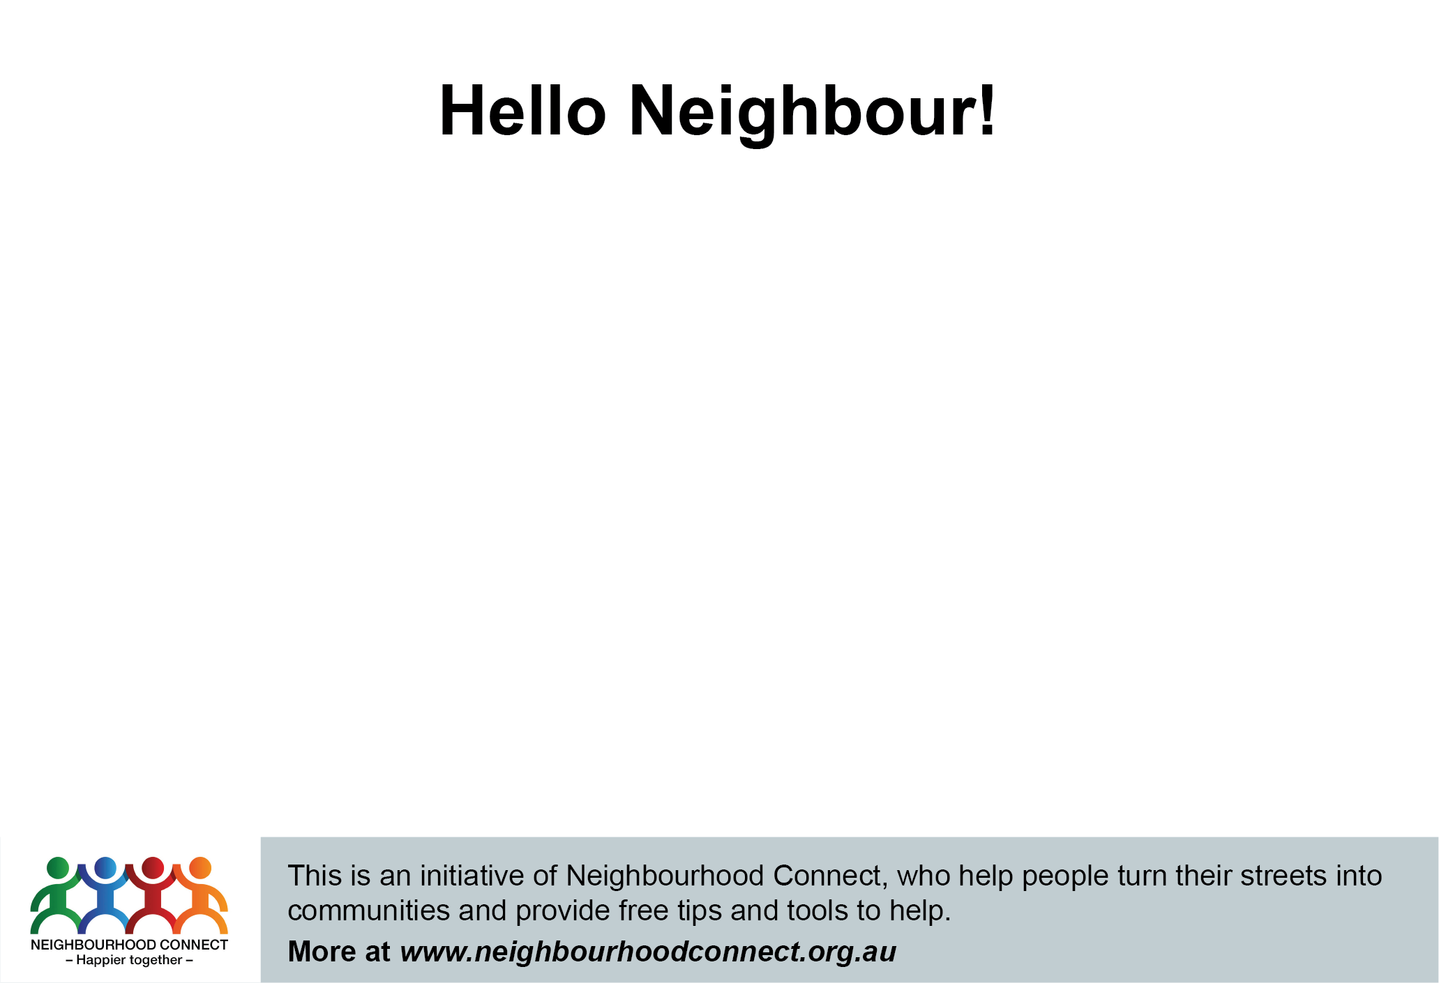

Hi, I’m < Insert name>, one of your neighbours on <Insert street name>. The coronavirus has made many of us realise how important our neighbours are ...so I'm reaching out to stay connected.

I'm planning to arrange a neighbourhood event to meet you soon, as the physical distancing rules relax and everyone feels safe to do so. In the meantime, I'm making a list of people who are interested in joining me, to have a chat; help out; share ideas and start to get to know each other.

Please call .................... or email ………….....(optional)<or join the new Facebook Group at [www.Facebook.or/neighbourgroup](http://www.Facebook.or/neighbourgroup)> and I will be in touch for next steps.

Look forward to meeting you!

**Hello Neighbour!**

Hi, I’m < Insert name>, one of your neighbours on <Insert street name>. The coronavirus has made many of us realise how important our neighbours are ...so I'm reaching out to stay connected.

I'm planning to arrange a neighbourhood event to meet you soon, as the physical distancing rules relax and everyone feels safe to do so. In the meantime, I'm making a list of people who are interested in joining me, to have a chat; help out; share ideas and start to get to know each other.

Please call .................... or email ………….....(optional)<or join the new Facebook Group at [www.Facebook.or/neighbourgroup](http://www.Facebook.or/neighbourgroup)> and I will be in touch for next steps.

Look forward to meeting you!



Hi, I’m < Insert name>, one of your neighbours on <Insert street name>. The coronavirus has made many of us realise how important our neighbours are ...so I'm reaching out to stay connected.

I'm planning to arrange a neighbourhood event to meet you soon, as the physical distancing rules relax and everyone feels safe to do so. In the meantime, I'm making a list of people who are interested in joining me, to have a chat; help out; share ideas and start to get to know each other.

Please call .................... or email ………….....(optional)<or join the new Facebook Group at [www.Facebook.or/neighbourgroup](http://www.Facebook.or/neighbourgroup)> and I will be in touch for next steps.

Look forward to meeting you!

Hi, I’m < Insert name>, one of your neighbours on <Insert street name>. The coronavirus has made many of us realise how important our neighbours are ...so I'm reaching out to stay connected.

I'm planning to arrange a neighbourhood event to meet you soon, as the physical distancing rules relax and everyone feels safe to do so. In the meantime, I'm making a list of people who are interested in joining me, to have a chat; help out; share ideas and start to get to know each other.

Please call .................... or email ………….....(optional)<or join the new Facebook Group at [www.Facebook.or/neighbourgroup](http://www.Facebook.or/neighbourgroup)> and I will be in touch for next steps.

Look forward to meeting you!