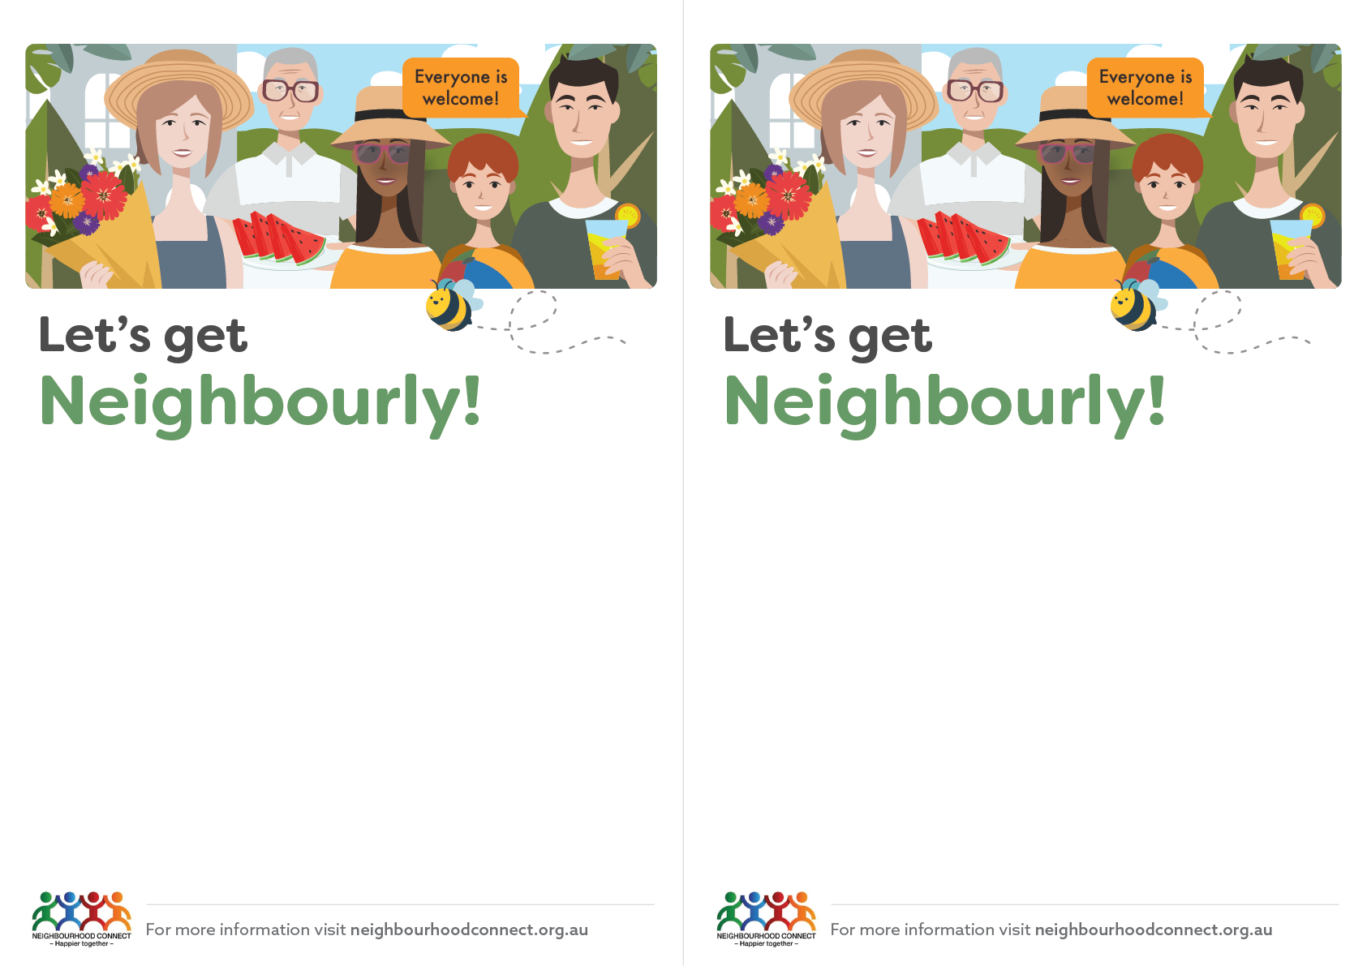

Hi, I’m/We are one of your neighbours who is interested in creating a more connected and friendly neighbourhood. If you like the idea of knowing more people, sharing ideas and helping each other, please join us at this friendly gathering.

Saturday/Sunday Day/Month/Year at Time

Insert venue name,

123 Street, Suburb

Please bring eg. food, drink, cup, cutlery…

RSVP to firstname at 0412 345 678 or

[insertemail@email.com.au](mailto:insertemail@email.com.au)*.*

I/We look forward to meeting you! Firstname/s and street

*If you can’t come but would like to be involved in future events please let me/us know.*

Hi, I’m/We are one of your neighbours who is interested in creating a more connected and friendly neighbourhood. If you like the idea of knowing more people, sharing ideas and helping each other, please join us at this friendly gathering.

Saturday/Sunday Day/Month/Year at Time

Insert venue name,

123 Street, Suburb

Please bring eg. food, drink, cup, cutlery…

RSVP to firstname at 0412 345 678 or

[insertemail@email.com.au](mailto:insertemail@email.com.au)*.*

I/We look forward to meeting you! Firstname/s and street

*If you can’t come but would like to be involved in future events please let me/us know.*