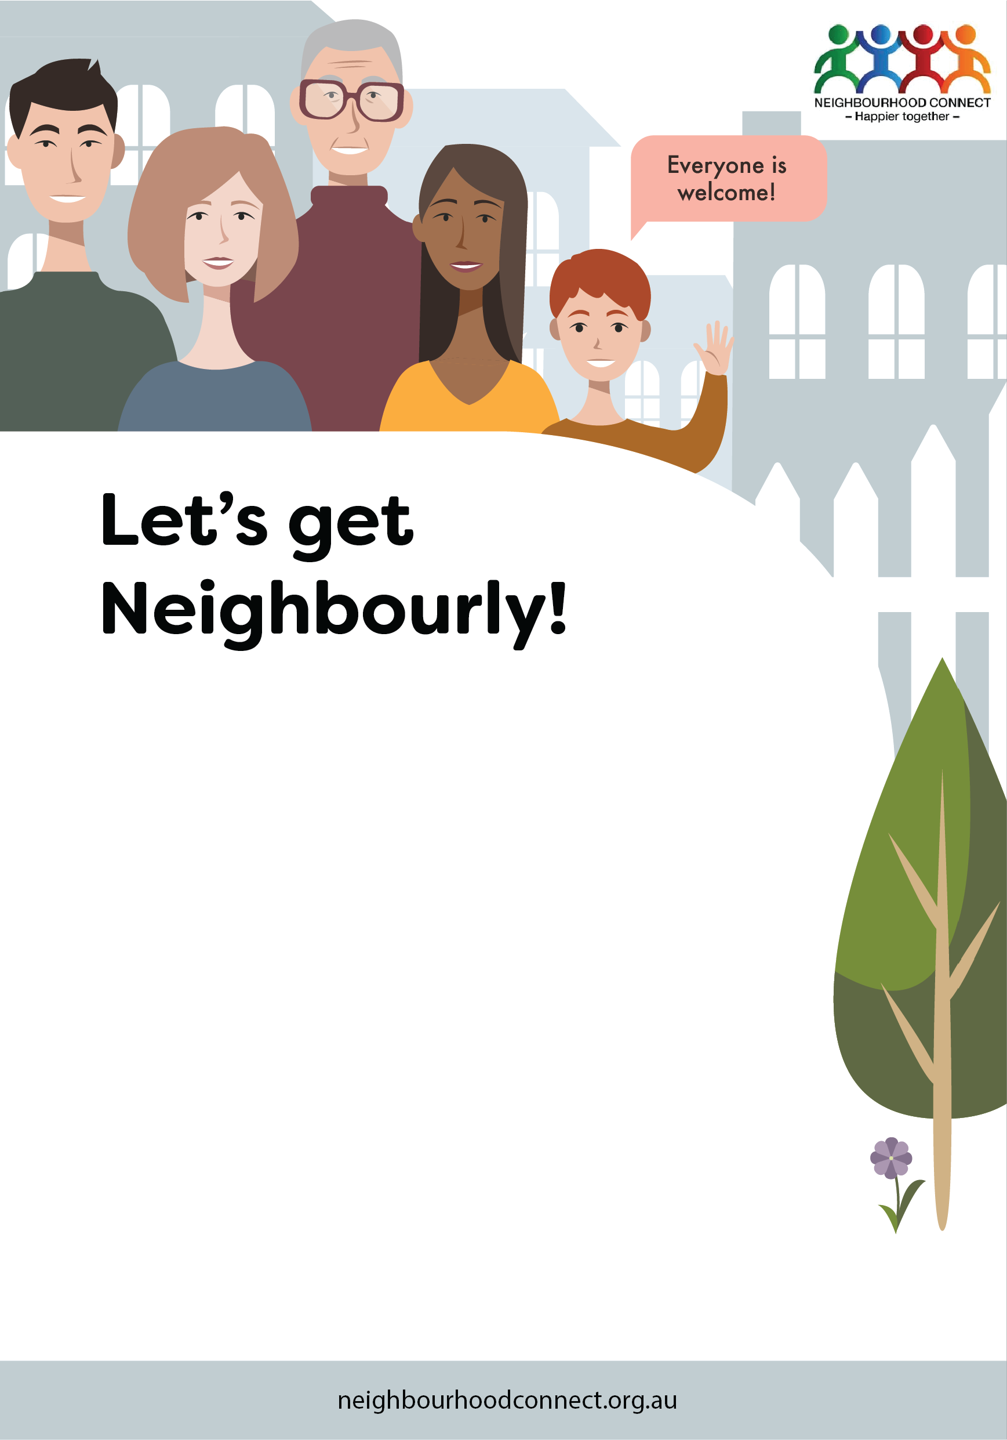

Hi, I’m/We are one of your neighbours who is interested in creating a more connected and friendly neighbourhood. If you like the idea of knowing more people, sharing resources and ideas and getting to know each other, please join us at this friendly gathering.

I/We look forward to meeting you! First name/s and street

XX/02/2021 at 12:30 P.M.

Insert venue name,

123 Street, Suburb

RSVP to first name at 0412 345 678 or

[insertemail@email.com.au](mailto:insertemail@email.com.au)*.*

*(If you can’t come but would like to be involved in future events,*

Hi, I’m/We are one of your neighbours who is interested in creating a more connected and friendly neighbourhood. If you like the idea of knowing more people, sharing resources and ideas and getting to know each other, please join us at this friendly gathering.

I/We look forward to meeting you! First name/s and street

XX/02/2021 at 12:30 P.M.

Insert venue name,

123 Street, Suburb

RSVP to first name at 0412 345 678 or

[insertemail@email.com.au](mailto:insertemail@email.com.au)*.*

*(If you can’t come but would like to be involved in future events,*