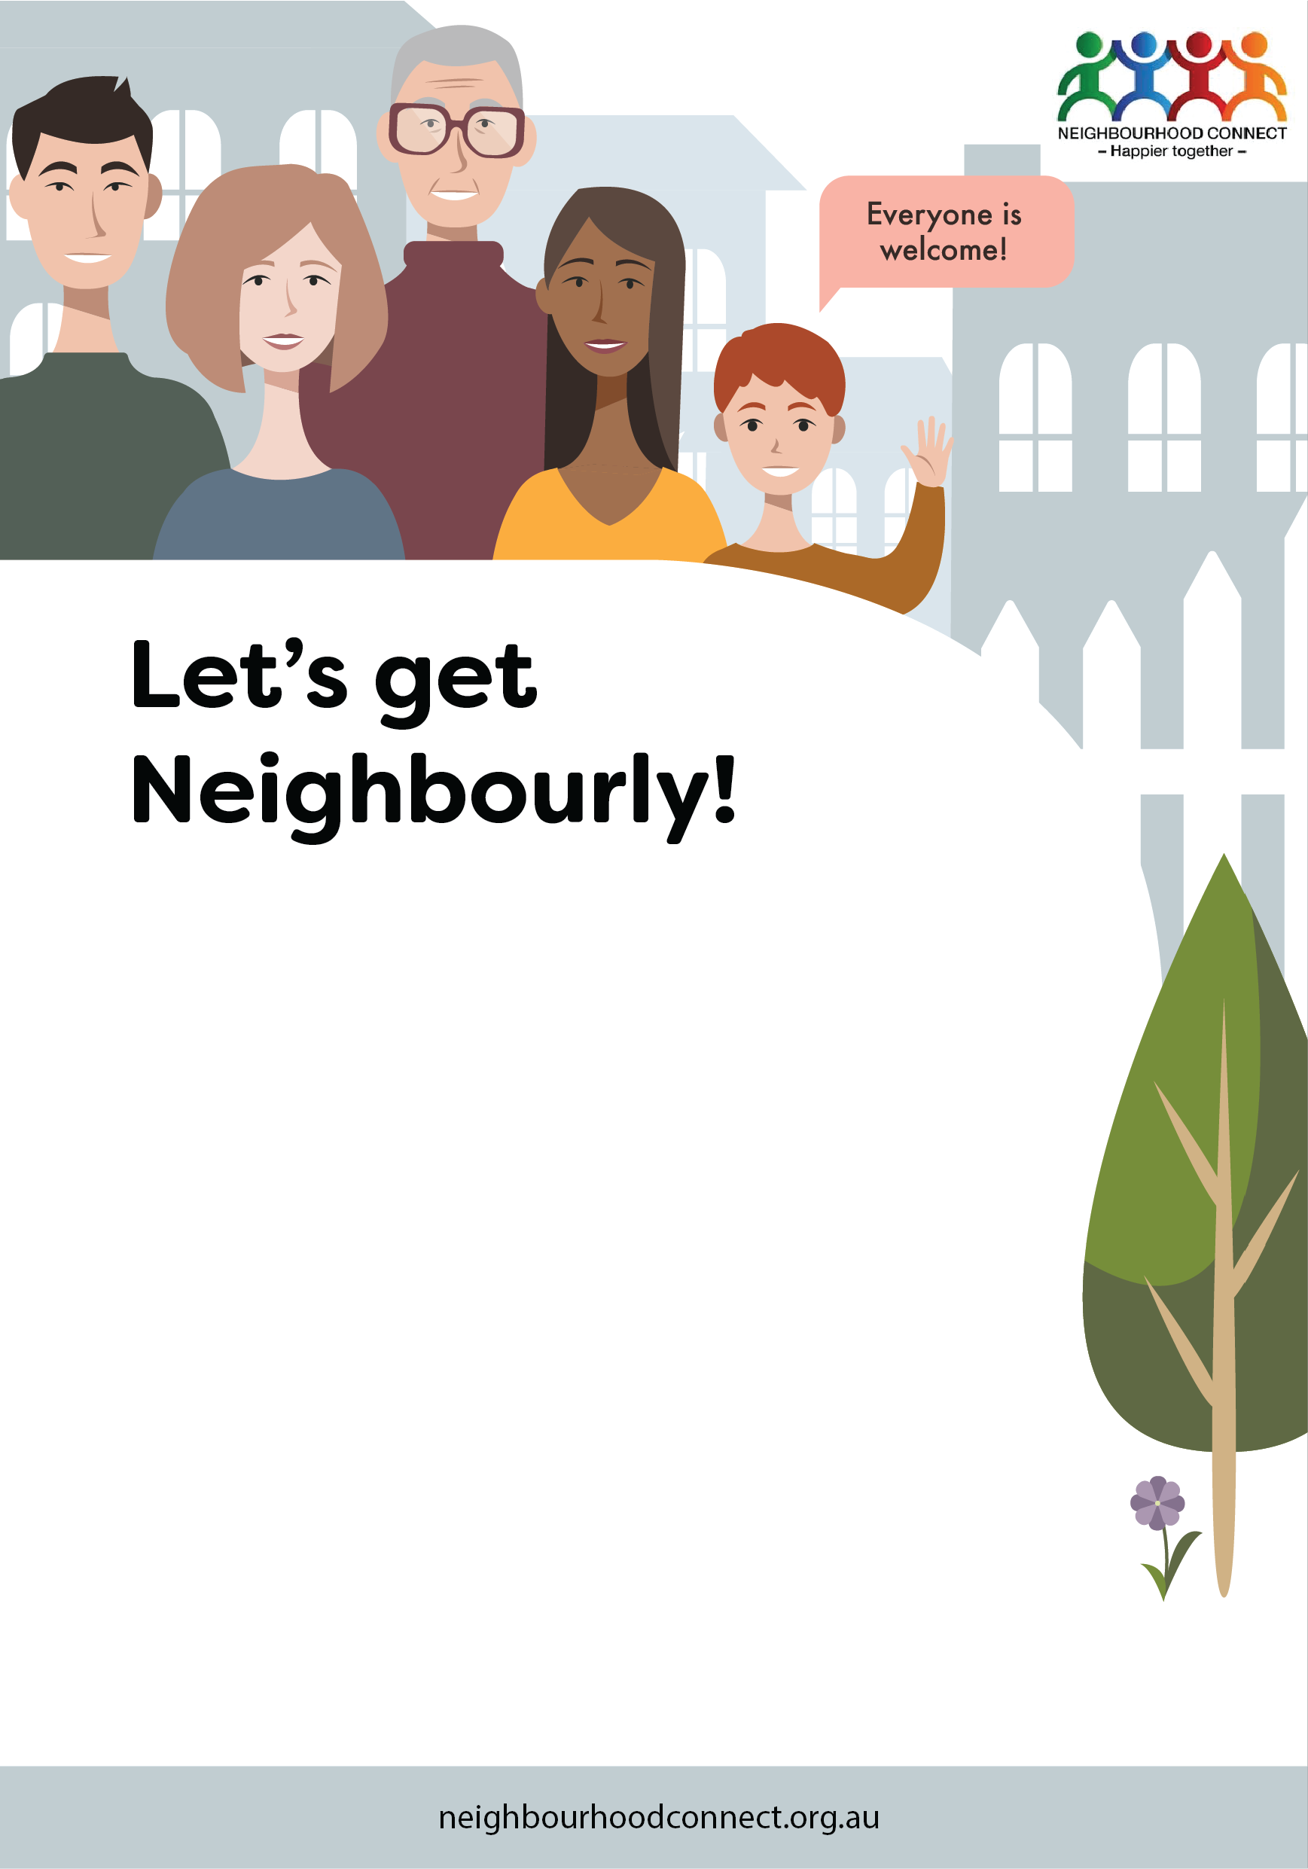

Hi, I’m/We are one of your neighbours who is interested in creating a more connected and friendly neighbourhood. If you like the idea of knowing more people, sharing resources and ideas and getting to know each other, please join us at this friendly gathering.

I/We look forward to meeting you!

First name/s and street

Date at Time

Insert venue name,

<Details of what to bring or other instructions here>

RSVP to first name at <mobile number> or

insertemail@email.com.au*.*

*(If you can’t come but would like to be involved in future events please let me/us know)*

**Please be mindful of COVID 19 guidelines and help**

**us all stay safe.**

Hi, I’m/We are one of your neighbours who is interested in creating a more connected and friendly neighbourhood. If you like the idea of knowing more people, sharing resources and ideas and getting to know each other, please join us at this friendly gathering.

I/We look forward to meeting you!

First name/s and street

Date at Time

Insert venue name,

<Details of what to bring or other instructions here>

RSVP to first name at <mobile number> or

insertemail@email.com.au*.*

*(If you can’t come but would like to be involved in future events please let me/us know)*

**Please be mindful of COVID 19 guidelines and help us**

**all stay safe.**