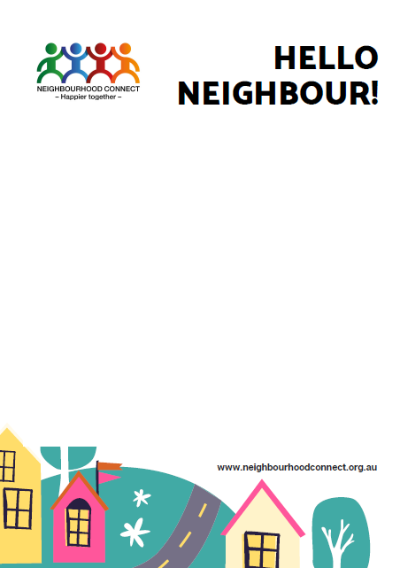



From: ________________________

Hello

We live at ___________________________

We know lots of people are worried about coronavirus right now.

If you:

* Self-quarantine and need food, books or kid’s activities delivered;
* Need a spare loo roll;
* End up in hospital and need help to feed pets or water the garden;
* Or something else?

Please let us know!

We may not be able to help but we will do our best to link you to someone in the community who can.

Here’s how you can contact us: ___________________

From: ________________________

Hello

We live at ___________________________

We know lots of people are worried about coronavirus right now.

If you:

* Self-quarantine and need food, books or kid’s activities delivered;
* Need a spare loo roll;
* End up in hospital and need help to feed pets or water the garden;
* Or something else?

Please let us know!

We may not be able to help but we will do our best to link you to someone in the community who can.

Here’s how you can contact us: ___________________